WHAT CAN A PSYCHOLOGY MAJOR DO FOR YOU?

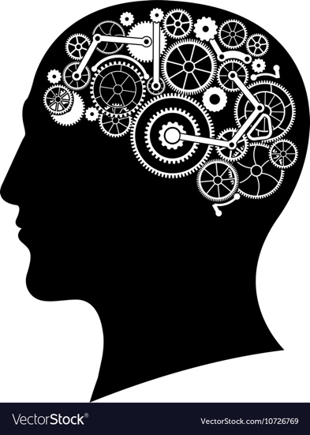
Through engagement in coursework, KSU psychology majors learn a variety of skills that are essential to any job:
- Critical thinking skills
- Interpersonal skills
- Problem-solving skills
- Research skills
- Writing skills
- Creative thinking skills
- Communication skills
- An understanding of human behavior

Our students acquire an incredible understanding of human behavior that is learned through several of our classes, including, but not limited to: Industrial-Organizational Psychology, Learning and Behavior, Human Development, Social Psychology, Abnormal Psychology, and Theories of Personality. Our students' unique understanding of human behavior makes them ideal candidates for nearly any industry (e.g. mental health agencies, marketing, sales, customer service, research, medicine, non-profit agencies etc.).

Research knowledge, critical/creative thinking, and writing and communication skills are essential concepts in both Research Methods and Statistical Applications. In addition, students are required to write APA Style papers on unique psychological topics and present findings to their classmates. Completion of semester-long projects coincide with developing the ability to correctly and ethically produce and interpret data.

The knowledge, awareness, and skills that PSYC majors have the opportunity to develop at KSU make these individuals great, well-rounded employees upon degree matriculation.
So, what can a psychology major do for YOU?

