Diigo Authentic Text Worksheet
While broad resources like news sites and grammar games are good to add to the FLRC Diigo at any time, we’d like to increase our collection of specific and contemporary articles, videos and more. Over the course of this semester, please use this worksheet to keep track of the links that you add to the Diigo. We will feature outstanding submissions on the FLRC’s Facebook and Instagram feeds!

This worksheet is organized into themes and subthemes (drawn from the College Board’s AP exam curriculum). Your objective is to find a specific article, video or website that deals with each subtheme, something that instructors could use in a specific lesson or that you could use to help your tutees to explore another culture. Some examples are provided to give you an idea of what to look for. Try to look for a diversity of texts, including poems, songs, videos, infographics, and podcast episodes.

When you add the resource to the Diigo, be sure to tag it with its associated theme and subtheme. You can tag it in both English and the original language.

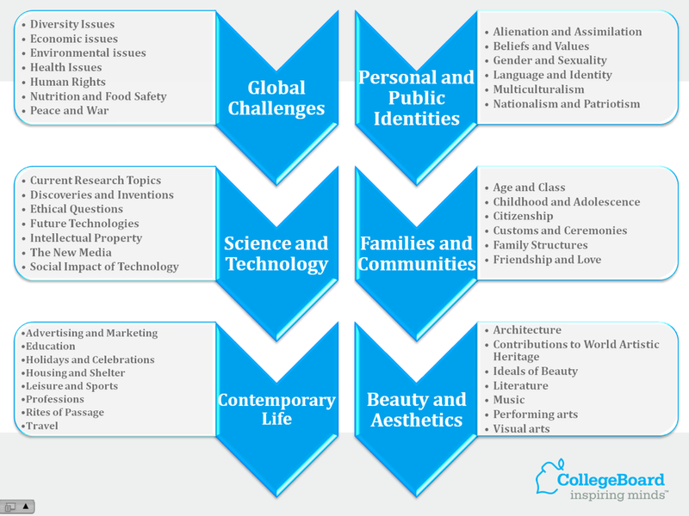

Global Challenges
What environmental, political, and social issues propose challenges to societies throughout the world? What are the origins of those issues? What are possible solutions to those challenges?
Diversity
Economic issues
Health
Human rights
Nutrition
Peace and War

Examples
- Article and video about “World Toilet Day” (and the humanitarian need for appropriate sanitation around the world)
- Illustration of key articles from the United Nation’s “Declaration of Universal Human Rights”

Science and Technology
How do developments in science and technology affect our lives? What factors have driven innovation and discovery in the fields of science and technology? What role does ethics play in scientific advancement?
Current Research
Discoveries or inventions
Ethical questions
New Media
Technology and society

Examples
- Article and infographic about social media use in France vs. the rest of the world
- Video about what future sustainable food source might look like

Contemporary Life
How do societies and individuals define quality of life? How is contemporary life influenced by cultural products, practices, and perspectives? What are the challenges of contemporary life?
Advertising and Marketing
Education
Holidays and Celebrations
Housing and Shelter
Leisure and Sports
Professions
Rites of Passage
Travel

Examples
- Interview and video about Francophone Carnival celebrations
- A poem about a dream house

Personal and Public Identities
How are aspects of identity expressed in various situations? How do language and culture influence identity? How does one’s identity develop over time?
Alienation and Assimilation
Beliefs and Values
Gender and Sexuality
Language and Identity
Multiculturalism
Nationalism and Patriotism

Examples
- A series of street interviews about the Francophone notion of “vivre ensemble” (or, tolerance and multiculturalism)
- A podcast episode about identity, geography and other people’s perceptions

Families and Communities
What constitutes a family in different societies? How do individuals contribute to the well-being of communities? How do the roles that families and communities assume differ in societies around the world?
Age and Class
Childhood Adolescence
Citizenship
Customs and Ceremonies
Family Structures
Friendship and Love

Examples
- Music video for Stromae’s “Papaoutai”
- Article and infographic about non-traditional families

Beauty and Aesthetics
How are perceptions of beauty and creativity established? How do ideals of beauty and aesthetics influence daily life? How do the arts both challenge and reflect cultural perspectives?
Architecture
World Artistic Heritage
Ideals of Beauty
Literature
Music
Performing Arts
Visual Arts

Examples
- Trailer for a biopic about French painter Séraphine
- Virtual visit to the Impressionist and Post-Impressionist Exhibit at the Musée d’Orsay in Paris

