MAPW FALL 2018 Final Schedule
Summary

Applied Writing Credits

PRWR 6240/01 Technical Writing TUES 6:30pm-9:15pm EB 235 S. Figueiredo
PRWR 6440/01 Professional and Academic Editing THUR 6:30pm-9:15pm EB 235 E. Giddens
PRWR 7900/01 Special Topics: Travel Writing TUES 6:30pm-9:15pm EB 140 L.Niemann

Composition and Rhetoric Credits
PRWR 6150/01 Context, Style and Audience in Professional Writing WED 6:30pm-9:15pm EB 235 T. Harper
PRWR 6500/01 Teaching Writing in HSs and Colleges MON 2:00pm-4:45pm EB140 L . McGrath

Creative Writing Credits
PRWR 6455/01 Genres of Creative Writing TUES 5:00pm-7:45pm EB 231 T. Grooms
[Cross Listed with WRIT 3000/01]
PRWR 6460/01 Fiction Writing MON 6:30pm-9:15pm EB 235 W. Rice
PRWR 6490/01 Screen and Television Writing THUR 6:30 -9:15 PM EB231 G. Fulton
PRWR 7900/01 Special Topics: Travel Writing TUES 6:30pm-9:15pm EB 140 L.Niemann

Directed Study, Internship and Capstone Credits
PRWR7950 Directed Study (student arranges with faculty member)
PRWR7960 Capstone
PRWR7600 Internship L. Smith-Sitton

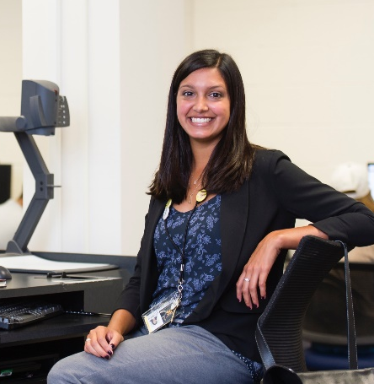
Spring 2018 Schedule Details

Shannan Rivera prepares to teach her Fall 2017 composition class

Applied Writing Credits
- PRWR 6240/01 Technical Writing TUES 6:30pm-9:15pm EB 235 S. Figueiredo
An intensive workshop focused on creating technical documents for clients, consumers, and the general public. Topics addressed will include the history, function, theory, and ethical practice of technical writing. Students will become more capable and informed technical writers and potential leaders in their organizations. Credits: 3-0-3

- PRWR 6440/01 Professional and Academic Editing THUR 6:30pm-9:15pm EB 235 E. Giddens

The study and practice of professional and academic(trade, professional, educational, and scholarly) editing for magazines, journals, books, and textbooks. Editorial divisions of labor and approaches and responsibilities of editors, along with the introduction to text development, acquisition, and line editing.
Credits: 3-0-3

- PRWR 7900/01 Special Topics: Travel Writing TUES 6:30pm-9:15pm EB 140 L.Niemann
This is a course in writing literary travel narrative, a sub-genre of Creative Non-Fiction. We
will utilize workshop techniques to develop travel narratives. In addition to the focus on
writing, we will explore the politics, history, and ethics of travel writing and tourism.
Students will make oral presentations, participate in and lead group discussions, and write a
theoretical essay and a literary travel narrative. We will read examples of both literary,
theoretical, and practical writing in the genre.

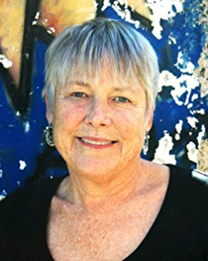

Dr. Linda Grant Niemann is the author of the forth coming travel narrative Learning Spanish which tells about her 20-year relationship with
Oaxaca, Mexico where she visits every summer. She is known for her three memoirs about railroading in Southwest where she worked as a brakeman for the Southern Pacific Railroad.

Recently she was told that she has the soul of an ethnologist. “I think that is true,” she says. “Working with people’s stories fascinate me and I see myself helping those stories get into print.”

Composition and Rhetoric Credits
- PRWR 6150/01 Context, Style and Audience in Professional Writing WED 6:30pm-9:15pm EB 235 T. Harper
A study of the ways context, stylistic choices, and audience influence all areas of writing in action, whether in the workplace, on the Internet, in publishing, or in the classroom. Course will focus on the creation of specific texts, many by the students themselves, with attention to the rhetorical traditions behind all spoken and written acts. Credits: 3-0-3

- PRWR 6500/01 Teaching Writing in HSs and Colleges MON 2:00pm-4:45pm EB140 L. McGrath
An investigation into the theories and practices that have shaped writing instruction over the past thirty years. Students will examine student-centered instruction, writing process theories, current methods of assessment, technologies of writing, and other important advances in order to produce curricular design for high school and college writing classes. Credits: 3-0-3

Pearlie Harris, Ed Gadrix and Dr. Giddens at Fall Orientation.

Creative Writing Credits
- PRWR 6455/01 Genres of Creative Writing TUES 5:00pm-7:45pm EB 231 T. Grooms
[Cross Listed with WRIT 3000/01]
This course is for MAPW students with no background in creative writing. It is cross listed with a course for undergraduate writers.
This course introduces students to the basic principles and building blocks of creative writing. As such, it is required of all students whose concentration or whose support area is creative writing, making it a prerequisite to all creative writing courses offered in the MAPW Program. This course will be especially valuable to students whose concentration is not creative writing but who have selected it as their support area. Students with appropriate expertise in creative writing may petition the director of the MAPW Program for a waiver of this course and enroll in the next one. The course focuses on the theory behind creative writing as well as the practice of it, making it a combination of seminar and workshop. Credits: 3-0-3

- PRWR 6460/01 Fiction Writing MON 6:30pm-9:15pm EB 235 W. Rice
Workshop course in the writing of fiction. Short stories and novellas may be studied. Small group critique, one-to-one conferences and peer revision techniques may be used.
PRWR 6490/01 Screen and Television Writing THUR 6:30 -9:15 PM EB231 G. Fulton
This course is designed for those beginning graduate students who wish to have some experience in the genre. It is a workshop course in writing for cinema, radio and television. Study and practice in effective screenplay writing techniques, on air report writing, on screen news writing and the principles of script writing, evaluation and promotion will be examined. Prerequisite: None. Credits: 3-0-3
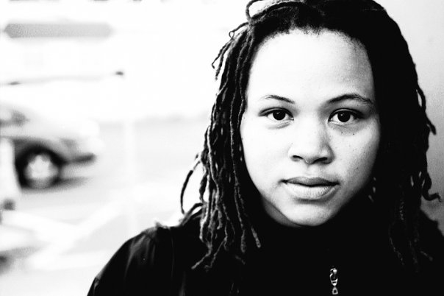
Gabrielle Fulton is Visiting Scholar of Screen Writing this semester. Her short film Ir/Reconcilable was broadcasted on HBO. Ir/Reconcilable was an official selection at the 2014 American Black Film Festival in New York City and was honored as a finalist in the HBO Short Film Competition. The film, starring Jasmine Guy, Dick Gregory, and Crystal Fox, was also selected for the 2015 Atlanta Film Festival. Other creative work includes directing the documentary short If We So Choose about the integration of The Varsity restaurant in Athens, GA. Other “non-scripted” work includes her Hip Hop Diaspora project which was optioned by MTV Networks and directing a television pilot for The Center, an international casting show. Gabrielle has a BA in History-Sociology from Columbia University and an MFA in Writing for the Screen & Stage from Northwestern University. She is also an accomplished playwright and her plays have been staged at Atlanta’s Alliance Theatre’s Hertz Stage, MetroStage in Alexandria, VA, and Horizon Theatre in Atlanta, where she was the 2012 playwright-in-residence.

- PRWR 7900/01 Special Topics: Travel Writing TUES 6:30pm-9:15pm EB 140 L.Niemann
SEE ABOVE

Directed Study, Internship and Capstone Credits
- PRWR7950 Directed Study (student arranges with faculty member) See guidelines at http://mapw.hss.kennesaw.edu/resources/

- PRWR7960 CRN50846 Capstone. See guidelines at http://mapw.hss.kennesaw.edu/resources/

- PRWR7600 CRN50846 Internship
Arrange with Dr. Lara Smith-Sitton, Director of Community Engagement at lsmith11@kennesaw.edu)

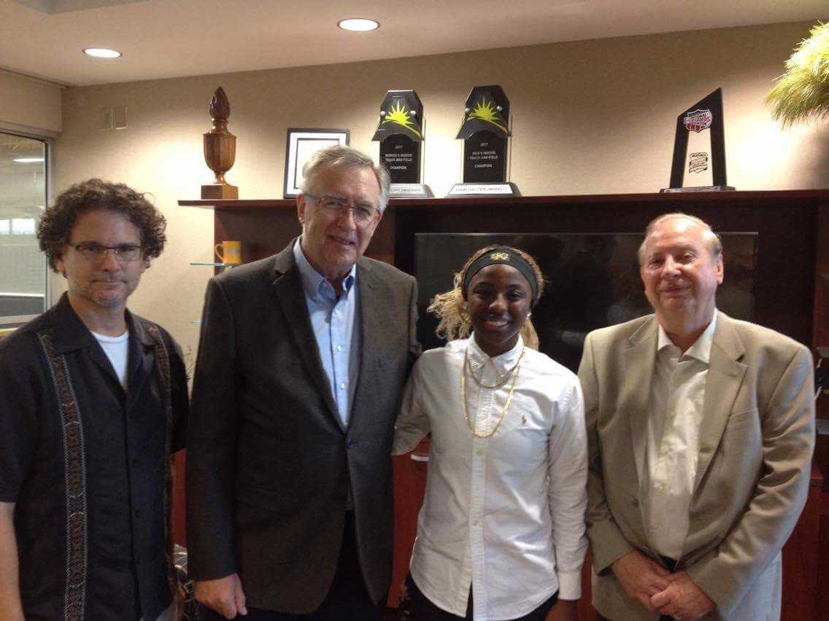
The Taber Scholarship is given in memory of MAPW Alumna Ellen Taber. Here English Professor Darren Crovitz, MAPW Alumnus Jeff Cebulski, Scholarship Winner Alexis Starks, and MAPW Professor Emeritus Bob Barrier at the Scholarship award ceremony in September, 2017.

