Schedule for MAPW Fall 2018
SUMMARY

Core course/ All Concentrations Required
PRWR 6000/01 Issues and Research in Professional Writing Christopher Palmer MON 6:30-9:15 PM EB 235 CRN 86674

All Concentrations Credits
PRWR 6100/01 Readings for Writers (Cross listed with AMST 7240 Railroads in American Life) Linda Niemann THUR 6:30-9:15 PM EB 231 CRN 86675
PRWR 7900/02 Research Methods for Writers Jeanne Bohannon THUR 6:30-9:15 PM EB 250 CRN 86898
[
Applied Writing Credits
PRWR 6550/01 Document Design and Desktop Publishing Sergio Figueiredo TUE 6:30-9:15 PM EB 266 CRN 86685
PRWR 7900/01 (Cross listed with PAD 7900) Public Policy Writing Elizabeth Giddens THUR 6:30-9:15 PM EB 235 CRN 86692
PRWR 6800/01 Careers in the Literary Arts JoAnn Loverde-Dropp WED 6:30-9:15 PM EB 266 CRN 86687

Composition and Rhetoric Credits
PRWR 6300/01 Understanding Writing as a Process Kim Haimes-Korn WED 2:00 - 4:45 PM EB 250 CRN 86676
PRWR 6650/01 Introduction to Literacy Studies Laura McGrath ONLINE CRN 86686
PRWR 7800/01 Practicum Teaching of Writing (2nd Year T.A.s only) STAFF MON 6:30 - 9:15 PM EB 266 CRN 86691

Creative Writing Credits
PRWR 6455/01 (Cross listed with WRIT 3000) Genres of Creative Writing Tony Grooms TUE 5:00 - 7:45 PM EB 231 CRN 86677
PRWR 6470/01 Poetry Writing Ralph Wilson WED 6:30-9:15 PM EB 231 CRN 86678
PRWR 6480/01 (Cross listed with WRIT 3110) Playwriting Gabrielle Fulton TUE 5:00 - 7:45 PM EB 235 CRN 86680
PRWR 7490/01 Advanced Screen and Television Writing Mitchell Olson WED 6:30 - 9:15 PM EB 235 CRN 86688
PRWR 7520/01 Advanced Creative Nonfiction Linda Niemann MON 6:30 - 9:15 PM EB 250 CRN 86689
PRWR 6800/01 Careers in the Literary Arts JoAnn Loverde-Dropp WED 6:30-9:15 PM EB 266 CRN 86687

Directed Study, Internship and Capstone Credits
PRWR7600/01 Internship L. Sitton (contact Lara Sitton) CRN 86690
PRWR7950 Directed Study (student arranges with faculty member)
PRWR7960/01 Capstone CRN 86795

Schedule for MAPW Fall 2018
DETAILED SCHEDULE
All classes are scheduled in the English Building (EB).
For catalog descriptions, go to the MAPW website.
For faculty biographies, go to the Faculty page.

Core course/ All Concentrations Required
PRWR 6000/01 Issues and Research in Professional Writing Christopher Palmer MON 6:30-9:15 PM EB 235 CRN 86674
This course introduces students to the three MAPW concentrations, focusing on key issues, theories, stylistic conventions, and research methods specific to each field and those that cut across all three concentrations. Students engage in reading and discussion, practice with rhetorical grammar and style, critique and application of research methodologies, and writing and revision strategies essential to professional writers’ work. Students build foundations for completing program requirements and course work within their concentration and support areas. Credits: 3-0-3

All Concentrations Credits
PRWR 6100/01 Readings for Writers: Railroads in American Life (Cross listed with AMST 7240) Linda Niemann THUR 6:30-9:15 PM EB 231 CRN 86675
This course is cross listed with MA in American Studies 7240, a graduate course.
Abraham Lincoln was a railroad lawyer, arguing the manifest destiny rights of an east-west current of travel across the Mississippi. The real John Henry was short and from New Jersey. William S. Burroughs stole literary characters from the railroad hobo writer, Jack Black.

The North American railroad was the embodiment of Manifest Destiny. Its technology created the country we live in today. Along the way, it became many things to many people: employment, mobility, a symbol of ruthless power, opportunity, connection, and genocide. We will look at both what the railroad was and what it became as it was transformed by art, photography, literature, folklore, and music. Credits: 3-0-3

PRWR 7900/02 Research Methods for Writers Jeanne Bohannon THUR 6:30-9:15 PM EB 250 CRN 86898
This course introduces students to research methods commonly used by writers and engages students in practices of researched composing for a variety of contexts. Students learn to create and critically consume research reports by getting hands-on exposure to interviewing, survey design, and archival research. The course also teaches students how to perform basic qualitative and quantitative analyses and IRB-approved research. Credits: 3-0-3

[
Applied Writing Credits
PRWR 6550/01 Design for Publication Sergio Figueiredo TUE 6:30-9:15 PM EB 266 CRN 86685
This course focuses on the theory and practice of the design stages of the publishing industry, including designing for popular, professional, and scholarly publications in print, electronic, and hybrid formats. Students will learn the creative and rhetorical dimensions of design practice to produce high-quality publications, as well as how to collaborate with authors during the design process. Specific topics and assignments vary per semester and instructor. Credits: 3-0-3

Peggy Comin jokes in Molly Brodak’s Creative Nonfiction workshop.

PRWR 7900/01 (Cross listed with PAD 7900) Public Policy Writing Elizabeth Giddens THUR 6:30-9:15 PM EB 235 CRN 86692
This course is cross listed with MA in Public Administration 7900, a graduate course.
A writing course intended for students pursuing careers in government and other policy research organizations or offices. This course focuses on the contexts, audiences, documents, and writing processes that policymakers, program officers, and professional writers manage in order to establish policy and to communicate it to stakeholders and to the general public.

Course objectives:
- To introduce students to how government and other policy writers strategize, plan, and perform their work.
- To give students practice in planning and writing typical public policy documents such as legislative histories, position papers, petitions, proposals, briefing memos, letters, opinion statements, resolutions, testimony, and public comment.
- To develop students’ understanding of the ethical and legal issues relevant to public policy writing.
- To provide students with insight into the careers available in public policy writing in government agencies, nonprofit organizations, and corporations.
Texts:
Catherine F. Smith. Writing Public Policy: A Practical Guide to Communicating in the Policy Making Process, Oxford UP 2015.
John W. Swain and Kathleen Dolan Swain. Effective Writing in the Public Sector, Routledge 2014.
In addition, students will download and read several online reports available about topics that interest them individually. Credits: 3-0-3

The Crambo

cram·bo ˈkrambō/ n. A literary journal for graduate students

The Crambo is a graduate-student-run publication at Kennesaw State University in Kennesaw, Georgia. We publish graduate students' fiction, creative, nonfiction, poetry, drama, photography, and art. All graduate students from any university are encouraged to submit original work

PRWR 6800/01 Careers in the Literary Arts JoAnn Loverde-Dropp WED 6:30-9:15 PM EB 266 CRN 86687
The course will focus on contemporary literary magazine editing and publishing. It will develop a publication mission and strategy for a student publishing project, The Crambo Grants and fellowship writing as well as submissions-and-publications procedures, literary editing, literary promotions, and time management will be discussed. Prerequisite: None. Credits: 3-0-3

Composition and Rhetoric Credits
PRWR 6300/01 Understanding Writing as a Process Kim Haimes-Korn WED 2:00 - 4:45 PM EB 250 CRN 86676
PRWR 6300 provides an introduction to the field of composition studies. In this course, we will examine writing research, theory, and pedagogy, focusing particular attention on questions integral to understanding writing as a process. This course investigates issues relevant to writing instruction today and explores how theories of writing inform teaching practices. Students study approaches to teaching and assessing writing and produce curricular design for college writing classes. Credits: 3-0-3

PRWR 6650/01 Introduction to Literacy Studies Laura McGrath ONLINE CRN 86686
An overview of approaches for studying and shaping literacy in a range of social contexts, including workplaces, instructional settings, and the literary marketplace. This course will explore competing definitions of literacy and their implications for professional writers with students learning to use research about literacy to enhance their work as professional writers. Credits: 3-0-3

PRWR 7800/01 Practicum Teaching of Writing (2nd Year T.A.s only) STAFF MON 6:30 - 9:15 PM EB 266 CRN 86691
Guided and supervised practical experience in one concentration of the MAPW Program. Credits: 1-6 Credit Hours

Creative Writing Credits
PRWR 6455/01 (Cross listed with WRIT 3000) Genres of Creative Writing Tony Grooms TUE 5:00 - 7:45 PM EB 231 CRN 86677
This course is for students who have been accepted into the MAPW program, who wish to be introduced to the genres of poetry writing, playwriting and/or prose fiction writing. It is cross listed with a course for undergraduate writers. Graduate students are expected to do assignments beyond those expected of the undergraduates.

This course introduces students to the basic principles and building blocks of creative writing. As such, it is required of all students whose concentration or whose support area is creative writing, making it a prerequisite to all creative writing courses offered in the MAPW Program. This course will be especially valuable to students whose concentration is not creative writing but who have selected it as their support area. Students with appropriate expertise in creative writing may petition the director of the MAPW Program for a waiver of this course and enroll in the next one. The course focuses on the theory behind creative writing as well as the practice of it, making it a combination of seminar and workshop. Credits: 3-0-3

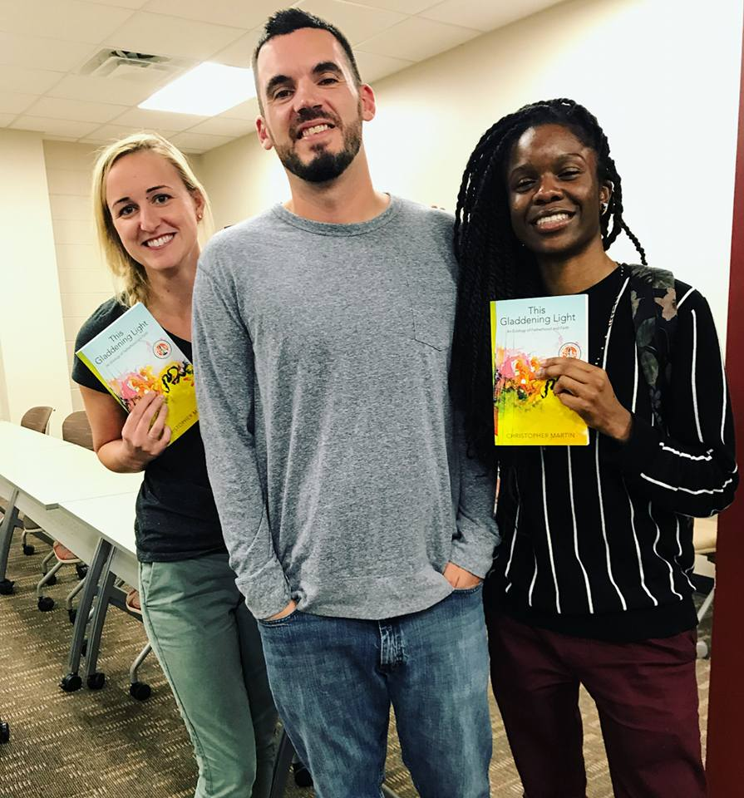

Alumnus Chris Martin (center) and members of Ellipses Undergraduate Writers’ Club at Chris’s KSU debut reading of This Gladdening Light.

PRWR 6470/01 Poetry Writing Ralph Wilson WED 6:30-9:15 PM EB 231 CRN 86678
Workshop course in the writing of poetry. Study of traditional, free verse, haiku and experimental forms by means of small group critique, one-to-one conferences and peer revision. Prerequisite: Those outside of the creative writing track must have taken PRWR 6455 or have permission of instructor. Credits: 3-0-3

PRWR 6480/01 (Cross listed with WRIT 3110) Playwriting Gabrielle Fulton TUE 5:00 - 7:45 PM EB 235 CRN 86680
This course is cross listed with an undergraduate course. It is designed for students who have been accepted into the MAPW program, who wish to be introduced to the genre of playwriting or to continue to develop introductory playwriting skills. Graduate students are expected to do assignments beyond those expected of the undergraduates.
An introductory writing workshop course exposing students to the principles of dramatic writing, including character, plot, dramatic structure, dialogue, exposition, setting, and creating theatrical imagery using examples from a diversity of plays, plays on screen, and students’ own work. Students will explore aesthetic concepts of writing for the stage while working toward the development of a personal, artistic vision. Credits: 3-0-3

PRWR 7490/01 Advanced Screen and Television Writing Mitchell Olson WED 6:30 - 9:15 PM EB 235 CRN 86688
In this workshop-oriented course, we will explore - and put into practice - the advanced techniques of writing for the screen. We will also discuss how to pitch, market, and sell your finished work. Students will have the option to start a new project from scratch or continue working on a project from PRWR 6490, with permission. Students who are interested in rewriting their scripts have the option of sending me a draft of the script. Please send this as a PDF attachment to olson.mit@gmail.com by July 15. You may be required to do drafts in addition to those required of students who are starting new scripts. Prerequisite: PRWR 6490

Dynamic Team to Lead Stage and Screen Writing for MAPW
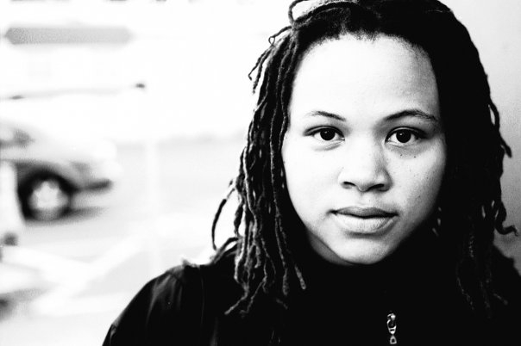
The English Department and the MAPW program are pleased to announce the hiring of Ms. Gabrielle Fulton and Mr. Mitch Olson to the positions of Assistant Professors of Stage and Screen Writing. The two will lead the development of playwriting, film and television writing courses for the MAPW program and the English undergraduate writing program. They will begin as tenure-track faculty in Fall Semester 2018.
Gabrielle Fulton
Gabrielle is presently KSU’s Visiting Scholar for Stage and Screen Writing and has been mentoring MAPW students since Fall of 2017. Her short film, Ir/Reconcilable was broadcasted on HBO. Starring Jasmine Guy and the late Dick Gregory, the film was an official selection at the 2014 American Black Film Festival in New York City. Her Hip Hop Diaspora Project was optioned for development by MTV Networks. Gabrielle has an MFA in Writing for the Screen & Stage from Northwestern University. She is also an accomplished playwright and her plays have been staged at Atlanta’s Alliance and Horizon theatres. “

Mitch Olson
Mitch has worked on the writing staffs of shows like Netflix’s “The Ranch” and Fox’s “The Grinder,” and has optioned a number of original scripts for both television and feature films. His full-length script, “The Lost Boy,” now in development, was a NexTV award winner in the feature category. He was also a finalist for the NYC Midnight Scriptwriting Challenge. Mitch holds and MFA in Screenwriting from Brooks Institute of Film and Photography.
Notably between the two, they have an extremely wide range of stage and screen experiences, including playwriting, dramaturgy, independent film making, feature and short film script writing, writing for various TV formats including reality shows, script supervision, and new media writing. “We are extremely fortunate,” says Tony Grooms, MAPW Interim Director, “to have two enthusiastic teaching professionals who will be taking KSU’s stage and screen writing to the next level. They will be proposing new courses and likely organizing a graduate certificate in screenwriting. MAPW is well-positioned to meet the writing expectations of Georgia’s TV and film industry.”
“Growing up in Athens and Atlanta,” Gabrielle said, “I never imagined that I would one day be able to live my Hollywood dreams right here in my own backyard. That’s why I’m thrilled to join the Kennesaw State University faculty to help cultivate and groom the next crop of Georgia dreamers.”

When asked about the importance of the writer to film, Mitch quoted famed film director Alfred Hitchcock, who said, "To make a fine film you need three things: a great script, a great script, and a great script." Mitch added, “I'm honored and thrilled to announce that, coming this fall, I will be joining the KSU faculty to teach students how to write (and sell) that great script. #Hootyhoo.”
PRWR 7520/01 Advanced Creative Nonfiction Linda Niemann MON 6:30 - 9:15 PM EB 250 CRN 86689
This is an advanced course in writing Creative Non-Fiction. Ideally, you will have a project in mind you want to work on this semester. Or, you can write a series of short pieces in different sub-genres. Because the beginning class has worked through Judith Barrington’s book on memoir, it would be advisable to do so if you are new to the genre. The class will be run as a workshop. Each session we will comment on the work of three or more class members, as well as discussing one of the reading list books. Class members will sign up to lead the discussion on one of the books, as well as for workshop times. We will work towards sending out one essay at the end of the semester to a venue of your choice. Credits: 3-0-3

PRWR 6800/01 Careers in the Literary Arts JoAnn Loverde-Dropp WED 6:30-9:15 PM EB 266 CRN 86687
The course will focus on contemporary literary magazine editing and publishing. It will develop a publication mission and strategy for a student publishing project, The Crambo Grants and fellowship writing as well as submissions-and-publications procedures, literary editing, literary promotions, and time management will be discussed. Prerequisite: None. Credits: 3-0-3

Directed Study, Internship and Capstone Credits
PRWR7600/01 Internship Lara Smith-Sitton (contact Lara Smith-Sitton) CRN 86690

Guided and supervised practical experience in one concentration of the MAPW Program. Credits: 1-6 Credit Hours

Dr. Lara Smith-Sitton,
Assistant Professor of English
and Director of Community Engagement.
Office: English Building (EB 27), Room 220
Email: lsmith11@kennesaw.edu
Phone: 470-578-3943
Fax: 470-578-9057

PRWR7950 Directed Study (student arranges with faculty member)
An intensive, advanced investigation of selected topics derived from individual courses of study. The content will be determined jointly by the instructor, the student, and the student’s advisor. The proposed course of study must be submitted to the graduate director by a deadline published each term for MAPW Committee approval. Credits: 3-0-3 (repeatable once). DEADLINE for FALL 18 enrollment is July 11, 2018.

PRWR7960/01 Capstone CRN 86795
A project designated as a thesis, portfolio or practicum and accompanied by a rationale for its purpose and design that involves electronic and/or print media and is relevant to the student’s concentration in professional writing. After submitting an approved capstone proposal, the candidate works under the direction and advice of two faculty members to produce the project. The candidate must submit the capstone project at least two weeks before either 1) a discussion about the project with the faculty committee, or 2) a public presentation about the project or a reading from the project for an audience of faculty and peers.Note: The candidate will consult with the capstone committee chair and committee member about which option to choose.
- Prerequisite: Completion of 27 credit hours in the MAPW program and at least four courses in the concentration; approval of capstone committee.
- Credits: 1-6 Credit Hours

See “Capstone-PRWR 7960” at http://mapw.hss.kennesaw.edu/resources/
DEADLINE: Proposals must be completed and turned into the Terri Brennen by July 25, 2018 for a Fall 2018 capstone enrollment. Please consider that completing the process as early as possible as the deadline is not a flexible one.

Fall Semester 2018 in Banner
CRN | Time | Days | Course Num/Sec | Instructor | Max | Avail | Location | SES
86674 | 6:30PM-9:15PM | M | PRWR 6000/01 | Palmer, Christopher | 15 | 15 | English Building- 235 | 1
86675 | 6:30PM-9:15PM | R | PRWR 6100/01 | Niemann, Linda | 10 | 10 | English Building- 231 | 1
86676 | 2:00PM-4:45PM | W | PRWR 6300/01 | Haimes-Korn, Kim | 15 | 15 | English Building- 250 | 1
86677 | 5:00PM-7:45PM | T | PRWR 6455/01 | Grooms, Tony | 8 | 8 | English Building- 231 | 1
86678 | 6:30PM-9:15PM | W | PRWR 6470/01 | Wilson, Ralph | 15 | 15 | English Building- 231 | 1
86680 | 5:00PM-7:45PM | T | PRWR 6480/01 | Fulton, Gabrielle | 10 | 10 | English Building- 235 | 1
86685 | 6:30PM-9:15PM | T | PRWR 6550/01 | Figueiredo, Serg | 15 | 15 | English Building- 266 | 1
86686 | TBA-TBA |  | PRWR 6650/W01 | McGrath, Laura | 15 | 15 | Not Assigned | 1
86687 | 6:30PM-9:15PM | W | PRWR 6800/01 | LoVerde-Dropp, JoAnn | 15 | 15 | English Building- 266 | 1
86688 | 6:30PM-9:15PM | W | PRWR 7490/01 | Olson, Mitchell | 15 | 15 | English Building- 235 | 1
86689 | 6:30PM-9:15PM | M | PRWR 7520/01 | Niemann, Linda | 15 | 15 | English Building- 250 | 1
86690 | TBA-TBA |  | PRWR 7600/01 | Smith-Sitton, Lara | 0 | 0 | Not Assigned | 1
86691 | 6:30PM-9:15PM | M | PRWR 7800/01 | Staff | 20 | 20 | English Building- 266 | 1
86692 | 6:30PM-9:15PM | R | PRWR 7900/01 | Giddens, Elizabeth | 10 | 10 | English Building- 235 | 1
86898 | 6:30PM-9:15PM | R | PRWR 7900/02 | Bohannon, Jeanne | 15 | 15 | English Building- 250 | 1
86795 | TBA-TBA |  | PRWR 7960/01 | Grooms, Tony | 0 | 0 | Not Assigned | 1

