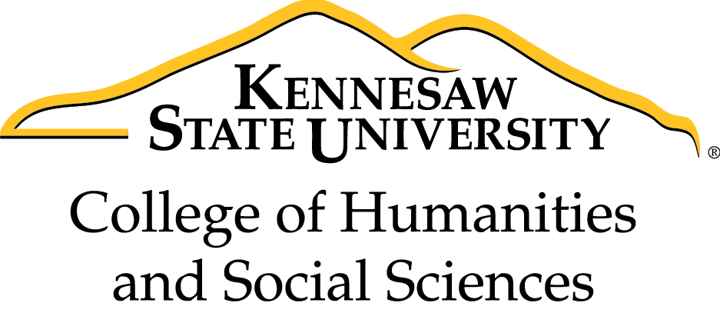

**2018-19 CHSS Staff**

**Book Group**

Join us as we read *Option B: Facing Adversity, Building Resilience, and Finding Joy*by Sheryl Sandberg and Adam Grant

*"Option B* combines Sandberg’s personal insights with Grant’s eye-opening research on finding strength in the face of adversity. It explores the stories of a broad range of people who have overcome challenges in their lives, identifies how we can best talk to and help others in crisis, and offers practical tips for creating resilient families, communities, and workplaces."

