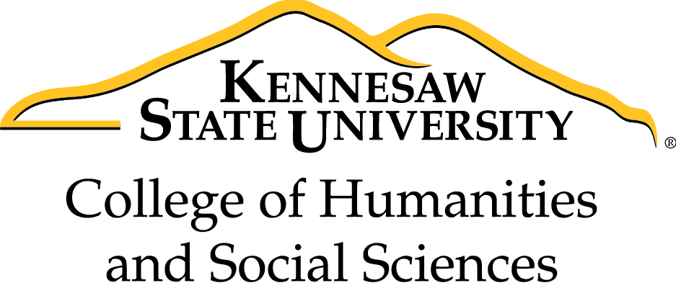

**2018-19 CHSS Faculty Development Series Book Group**

Join us as we read *The New Education* by Cathy Davidson.

*"*In *The New Education*, Cathy N. Davidson reveals that we desperately need a revolution in higher learning if we want our students to succeed in our age of precarious work and technological disruption. Journeying from elite private schools to massive public universities to innovative community colleges, she profiles iconoclastic educators who are remaking their classrooms by emphasizing creativity, collaboration, and adaptability over expertise in a single, often abstract discipline. Working at the margins of the establishment, these innovators are breaking down barriers between ossified fields of study, presenting their students with multidisciplinary, real-world problems, and teaching them not just how to think, but how to learn. *The New Education* ultimately shows how we can educate students not only to survive but to thrive amid the challenges to come.*"*

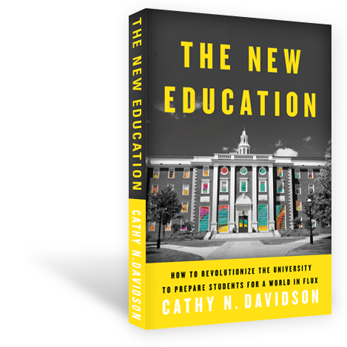

The first 20 faculty members to sign up for the group will receive a complimentary copy of the book.  An electronic copy of the book is also available through our KSU library.  We will select meeting dates after the group members are identified.  The CHSS book group will meet together four times during this academic year (October, November, February, and March).